TARENTO TRAINING SESSIONS

1. Git and Git hub

2. Database

3. Web Designing

4. Product Lifecycle

5. Agile software development

1

GIT AND GIT HUB

This session mainly focused on familiarizing the Git version controls through various Git commands available and also different features of the GitHub.

It was conducted by NSS on 30th December 2023 and 1st of January 2024.

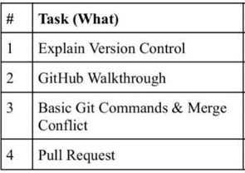

Description :

The four tasks included Explaining about the version control, a walkthrough of the GitHub and discussing about basic commands of git and merge conflict and pull requests.

From the two classes, an idea of how to create an account, and features like commit, branch, merge, staging area, and how to clone, fetch, pull, and push repositories were provided.

After these sessions, tasks were assigned initially to create an account, then to form a repository, clone a forked repository, create a pull request and commit all the changes.

2

DATABASE

This session mainly focused on the fundamentals of Database, PostgreSQL and ER diagrams.

It was conducted by RIT on 25th  and 27th of January 2024.

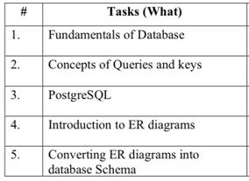

Description :

The Four tasks included Fundamentals of the database, concepts of queries and keys, PostgreSQL, ER diagrams, and converting them to schema.

The basic principles of database design, the significance of primary and foreign keys, and how queries are used to interact with the database are introduced. This session mainly aimed to provide an understanding of how databases function and the role of PostgreSQL as a powerful relational database management system. Entity-Relationship (ER) diagrams and the process of converting these diagrams into database schemas were discussed then. This session explained how ER diagrams serve were used for designing databases, to illustrate the relationships between different entities, how to transform these diagrams into practical database schemas.

After these sessions, tasks were assigned to create own ER diagrams to model a database, setup a PostgreSQL environment, and use different SQL queries.

3

WEB DESIGNING

This session mainly focused on the concepts of web designing and practical applications.

It was conducted on 29th  and 30th of January and 1st of February 2024.

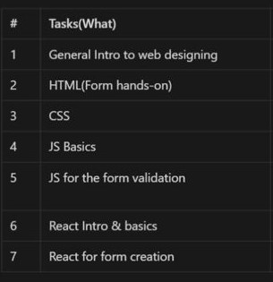

Description :

The main tasks included an introduction to web designing and HTML, CSS, and basics of JS and React.

The basics of HTML, to create and structure web pages, and form creation and using CSS, learning how to style web pages to enhance their visual appeal and usability were discussed. An introduction to JavaScript, included practical applications of JavaScript, such as form validation, to ensure that user inputs are correctly processed and stored are explained. React, a popular JavaScript library for building user interfaces, its core principles and its use in form creation are all discussed.

Following these sessions, a task to create a personal portfolio web page, showcasing their abilities and projects were given and an HTML and CSS project was also given, to reinforcing their understanding and proficiency in these technologies.

4

PRODUCT LIFE CYCLE

This session mainly focused to provide participants with a comprehensive understanding of the product life cycle (PLC) and its stages.

Description :

An introduction to the concept of the product life cycle and its importance in managing products from inception to decline. This included various stages of the product life cycle, including introduction, growth, maturity, and decline, etc. The reasons for using Product Life Cycle Management (PLM), emphasizing its role in maximizing product longevity, optimizing resources, and improving overall business strategy is discussed. The session also provided practical guidance on how to effectively use the product life cycle in planning and decision-making processes.

5

AGILE SOFTWARE DEVELOPMENT

This session mainly focused to provide participants with a comprehensive understanding Agile software development and its features.

Description :

In this session, participants were introduced to the concepts and methodologies of Agile practices. A detailed discussion of the Agile Manifesto, about the values and principles of Agile development which emphasize individuals and interactions over processes and tools, working software over comprehensive documentation, customer collaboration over contract negotiation, and responding to change over following a plan were discussed. The session also covered the Agile pyramid, and different methodologies like Scrum.